Exercise 6-3

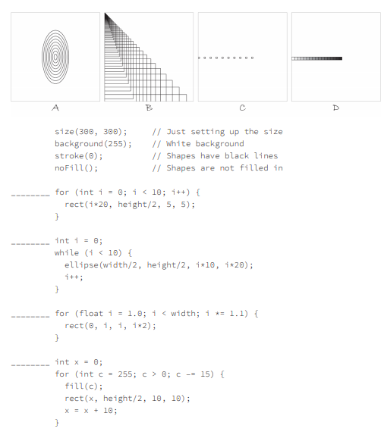

1. C
2. A
3. B
4. D